My Mother, Friend
Great Woman of God

She was soft, but she walked in STRENGTH!
She was pretty, but She walked in POWER!
She was feminine, but she walked in FAVOR!
She was virtuous, but she walked in VICTORY!

Heavenly Father,
I may not understand how
everything will work out, but I
trust you. I don’t see a way, but I
know you will make a way, I have
faith at this very moment you are
touching hearts, opening doors,
and lining up the right breaks and
right opportunities. Things may
look dark and bleak now, but I have
faith that my dawn is coming!
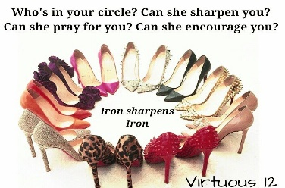
In Jesus’ name

